**CREATING DATABASE FOR ANALYSIS OF SUPERMART**

CREATE DATABASE supermart_grossery_sales;



**CREATE TABLE SUPARMART GROCERY SALES**

CREATE TABLE Supermart_Grocery_Sales(

Order_ID VARCHAR(50) NOT NULL,

Customer_Name VARCHAR(50) NOT NULL,

Category VARCHAR(50) NOT NULL,

Sub_Category VARCHAR(50)NOT NULL,

City VARCHAR(50) NOT NULL,

Order_Date DATE NOT NULL,

Region VARCHAR(50) NOT NULL,

Sales VARCHAR(50) NOT NULL,

Discount DECIMAL(20)NOT NULL,

Profit DECIMAL(20)NOT NULL,

State VARCHAR(50) NULL

)

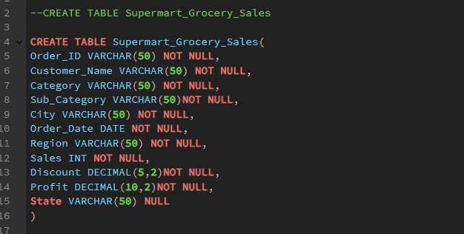

**IMPORT CSV DATASET TO PGSQL**

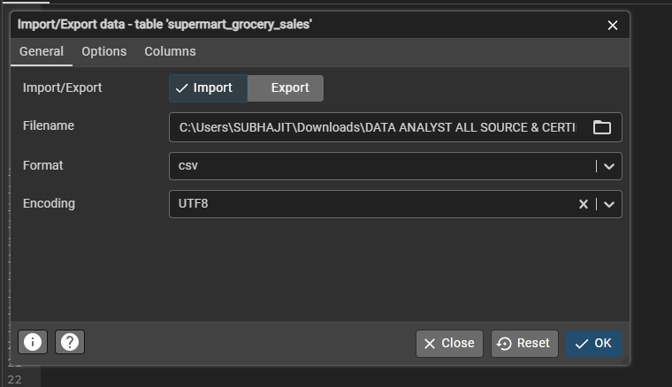

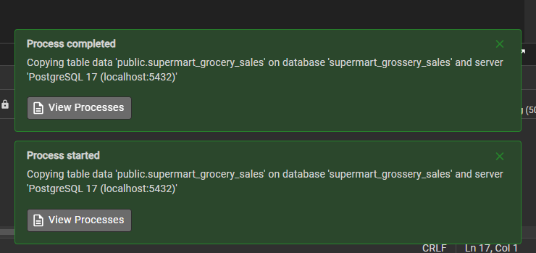

**CHECKED DATASET SUCESSFULY LOAD IN PGSQL**

SELECT * FROM Supermart_Grocery_Sales;

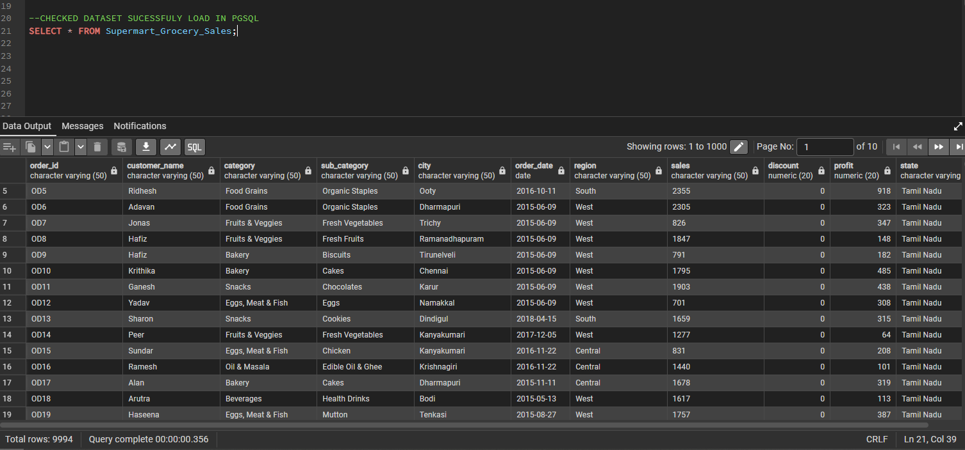

**BUISNESS PROBLEMS**

**1. Which product categories and subcategories contribute the most to total sales and profits?**

SELECT category, sub_category,

SUM(sales) AS Total_Sales,

SUM(profit) AS Total_Profit

FROM

Supermart_Grocery_Sales

GROUP BY category,sub_category

ORDER BY Total_Sales DESC, Total_Profit DESC;

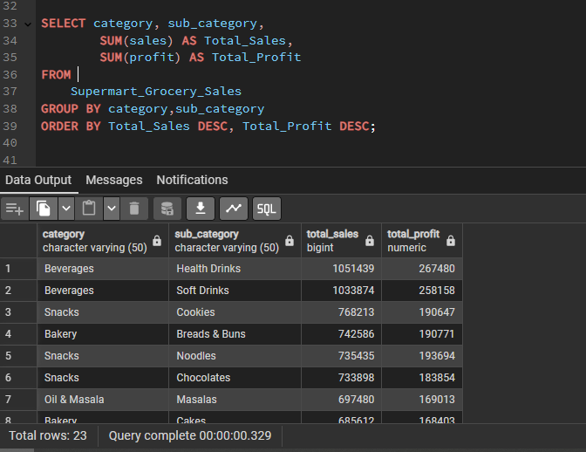

**2. Which regions and cities generate the highest revenue, and which ones underperform?**

**-- REGION & CITY GENERATE THE HIGHEST REVINUE**

SELECT region, city,

SUM(sales) AS Highest_Revenue

FROM

Supermart_Grocery_Sales

GROUP BY region, City

ORDER BY Highest_Revenue DESC

LIMIT 5; -- LIMIT TOP 5 REGION & CITY HIGHEST REVINUE

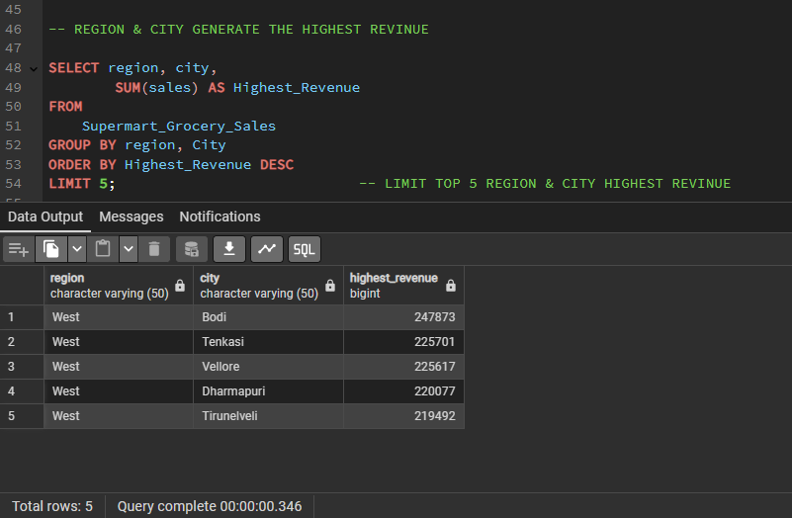

**-- UNDERPERFORMING REGION & CITY**

SELECT region, city,

SUM(sales) AS Lowest_Revenue

FROM

Supermart_Grocery_Sales

GROUP BY region, City

ORDER BY Lowest_Revenue ASC

LIMIT 5; -- LIMIT BUTTOM 5 REGION & CITY LOWEST REVINUE

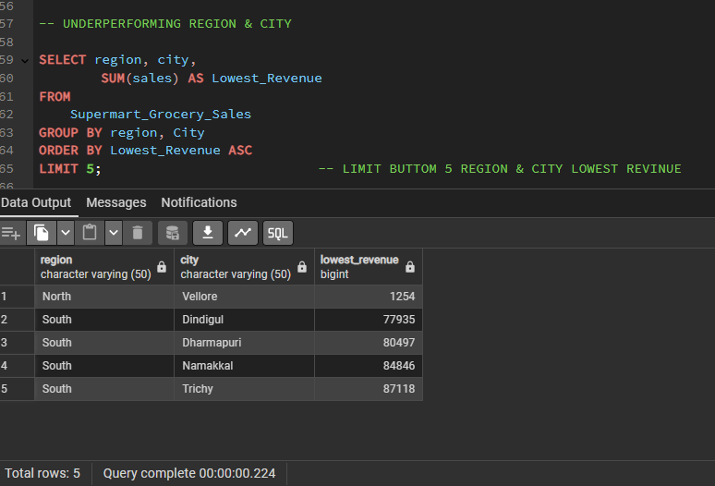

**3. Are higher discounts impacting profit margins negatively?**

SELECT

Discount,

ROUND(AVG(Profit / Sales) * 100, 2) AS Profit_Margin_Percentage

FROM Supermart_Grocery_Sales

GROUP BY Discount

ORDER BY Discount DESC;

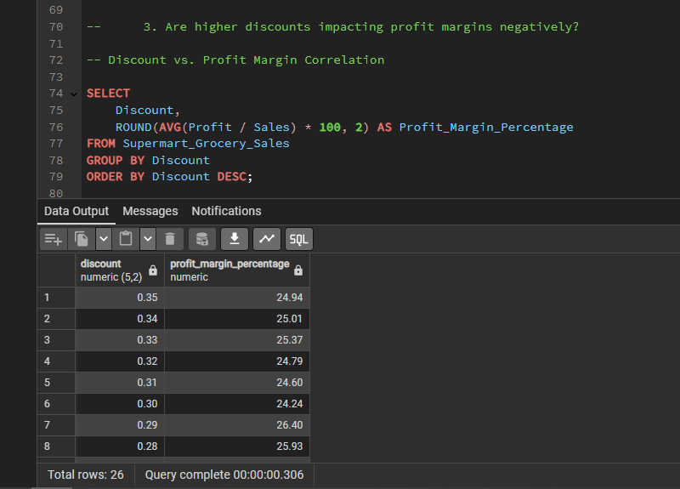

**-- Categories Most Affected by Discounts**

SELECT

Category,

Discount,

SUM(Sales) AS Total_Sales,

SUM(Profit) AS Total_Profit,

ROUND(AVG(Profit / Sales) * 100,2) AS Profit_Margin_Percentage

FROM Supermart_Grocery_Sales

GROUP BY Category, Discount

ORDER BY Discount DESC, Profit_Margin_Percentage ASC;

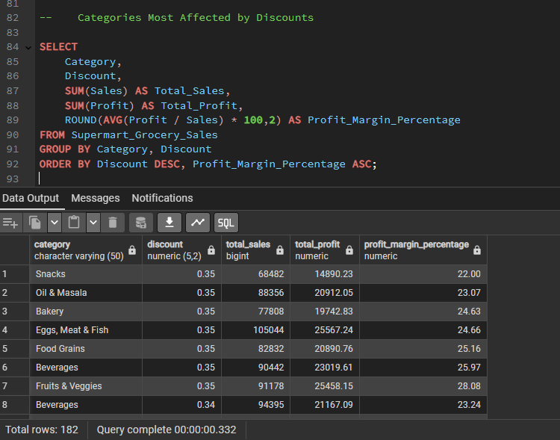

**4. How does profit vary across different product categories and regions?**

**-- Aggregate Profit by Category & Region**

SELECT Category, Region,

SUM(Profit) AS Total_Profits

FROM

Supermart_Grocery_Sales

Group BY

Category,Region

ORDER BY

Region, Total_Profits DESC;

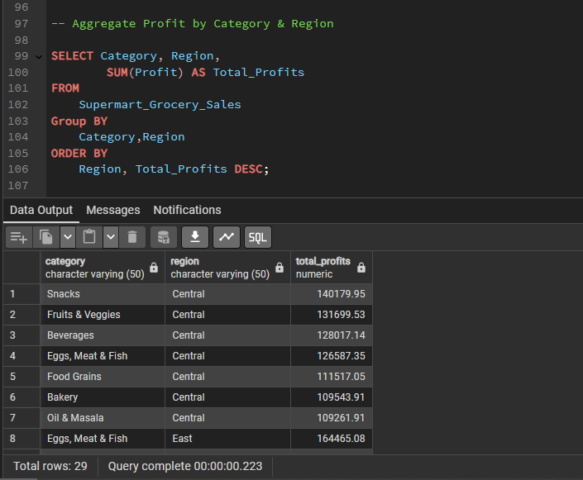

**5. Identifying the top customers based on purchase value.**

-- **TOP 10 CUSTOMER BASED ON TOTAL PURCHASE VALUE**

SELECT

Customer_Name,

SUM(Sales) AS Total_Purchase_Value

FROM Supermart_Grocery_Sales

GROUP BY Customer_Name

ORDER BY Total_Purchase_Value DESC

LIMIT 10;

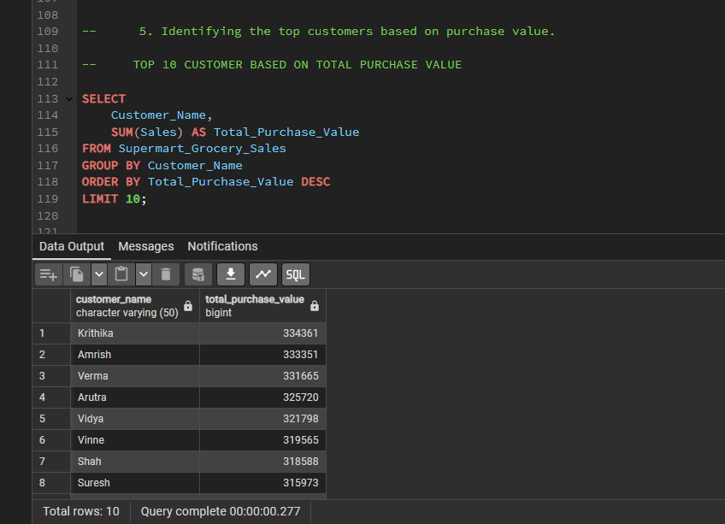

**6. Determining seasonal trends in sales and peak demand periods.**

-- Extract Month and Year for Sales Trend Analysis

SELECT

EXTRACT(YEAR FROM Order_Date) AS Year, -- Extract Year

EXTRACT(MONTH FROM Order_Date) AS Month, -- Extract Month

ROUND(SUM(Sales) /1000,2) ||'K' AS Total_Sales

FROM

Supermart_Grocery_Sales

GROUP BY Year,Month

ORDER BY Year,Month;

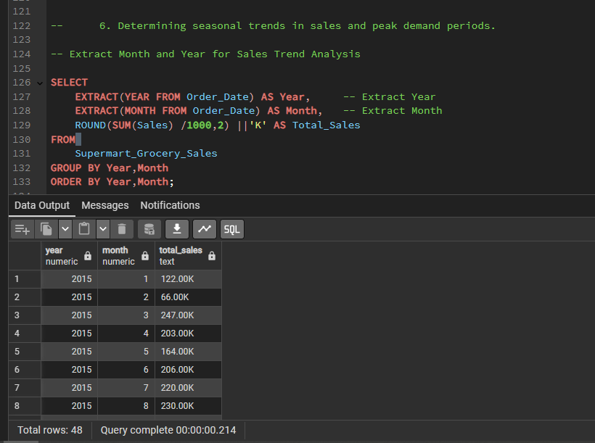

-- Quarter-Wise Trends

SELECT

EXTRACT(YEAR FROM Order_Date) AS Year, -- Extract Year

EXTRACT(QUARTER FROM Order_Date) AS Quarter, -- Extract Quarter

ROUND(SUM(Sales) /10000,2) ||'K' AS Total_Sales

FROM

Supermart_Grocery_Sales

GROUP BY Year, Quarter

ORDER BY Year, Quarter;

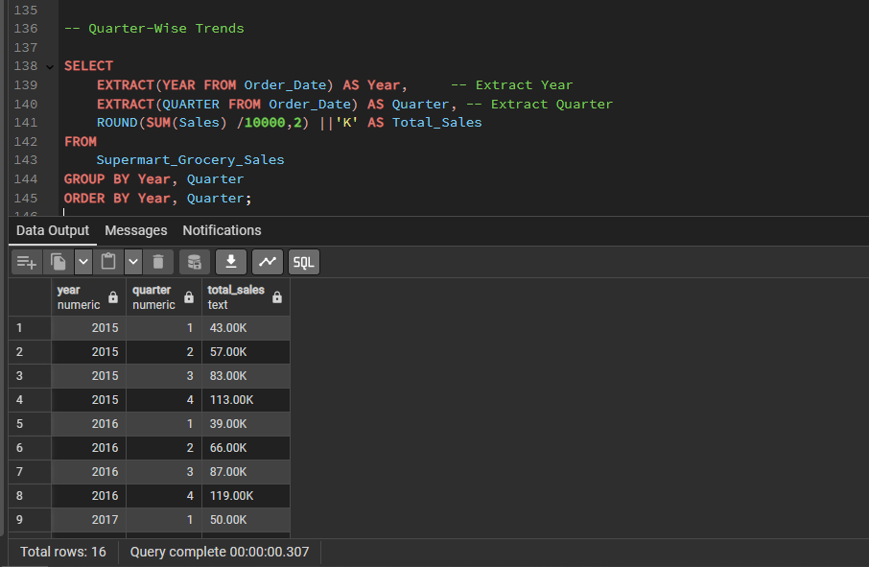

-- Peak Sales Days of the Week

SELECT

TO_CHAR(Order_Date, 'Day') AS Day_of_Week,

ROUND(SUM(Sales) / 10000,2) || 'K' AS Total_Sales

FROM

Supermart_Grocery_Sales

GROUP BY Day_of_Week

ORDER BY Total_Sales DESC;

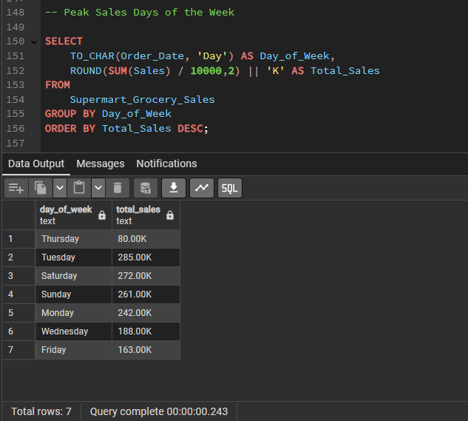

-- Monthly Sales Trends by Category

SELECT

CATEGORY,

EXTRACT(MONTH FROM Order_Date) AS Month,

SUM(sales) AS Total_Sales

FROM

Supermart_Grocery_Sales

GROUP BY CATEGORY, Month

ORDER BY CATEGORY, Month;

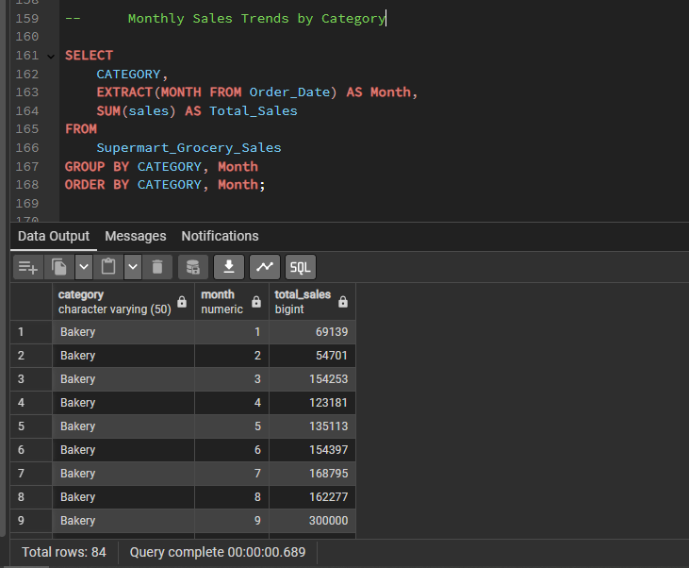

**7. Understanding which states and cities have the best and worst sales performance.**

-- This ranks cities from highest to lowest sales.

SELECT state,city,

SUM(sales) AS Total_sales

FROM

Supermart_Grocery_Sales

GROUP BY State,City

ORDER BY Total_sales DESC;

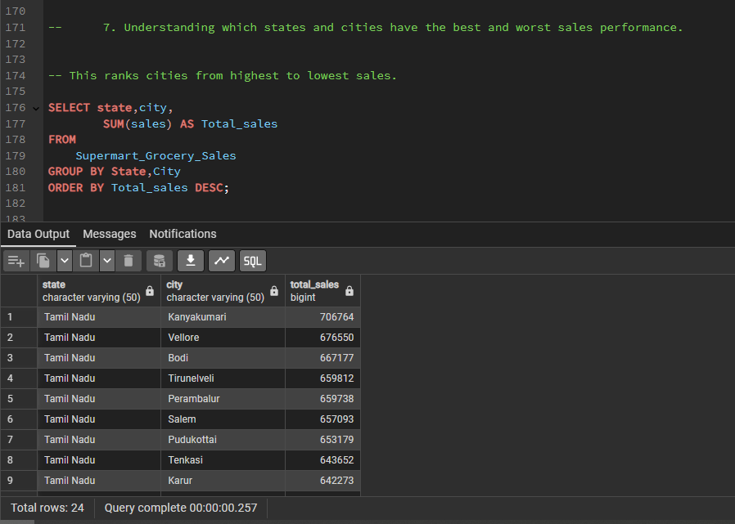

-- Top 5 Cities sales performance

SELECT city,

SUM(sales) AS Total_sales

FROM

Supermart_Grocery_Sales

GROUP BY City

ORDER BY Total_sales DESC

LIMIT 5;

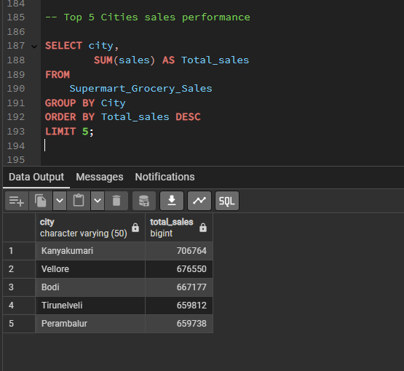

-- Worst 5 Cities sales performance

SELECT city,

SUM(sales) AS Total_sales

FROM

Supermart_Grocery_Sales

GROUP BY City

ORDER BY Total_sales ASC

LIMIT 5;

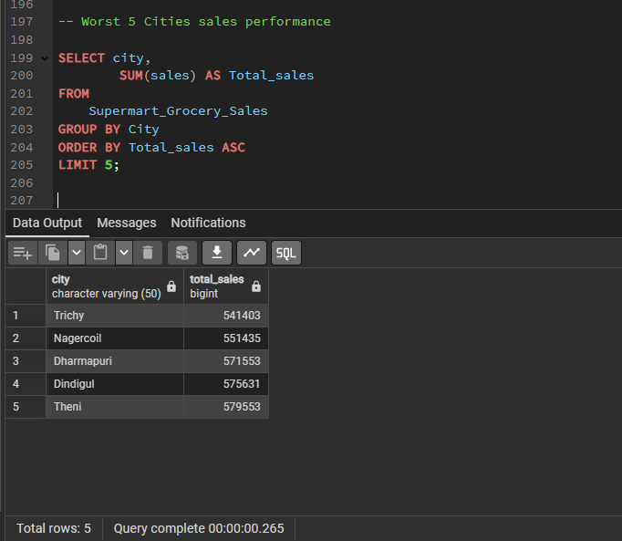

**8. Analyzing which regions require better marketing efforts to boost revenue.**

-- Regions with Low Total Sales

SELECT Region,

SUM(sales) AS Total_sales

FROM

Supermart_Grocery_Sales

GROUP BY Region

ORDER BY Total_sales DESC;

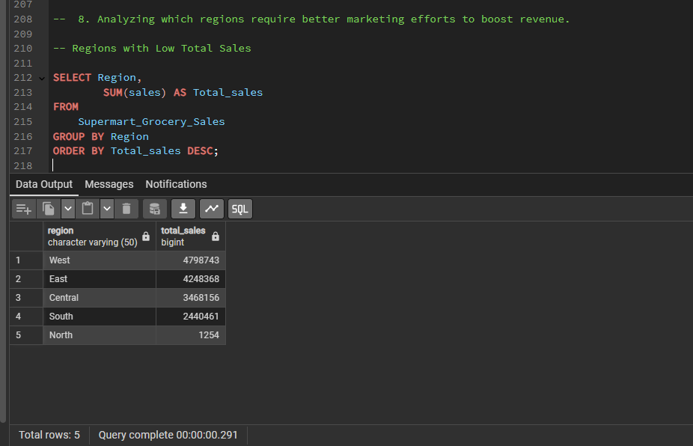

-- Regions with Low Profit Margins

SELECT Region,

SUM(sales) AS Total_Sales,

SUM(Profit) AS Total_Profits,

ROUND((SUM(profit) / SUM(sales)) *100,2) AS Ptofit_Margine_Percentage

FROM

Supermart_Grocery_Sales

GROUP BY Region

ORDER BY Ptofit_Margine_Percentage;

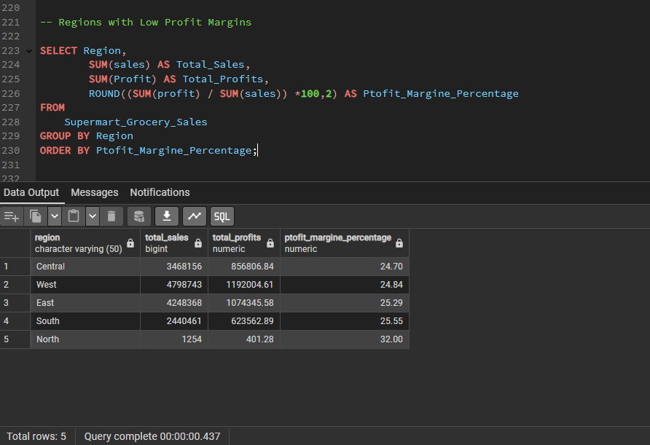

-- Regions Where Discounts Are Too High

SELECT

Region,

ROUND(AVG(Discount) * 100, 2) AS Avg_Discount_Percentage,

ROUND((SUM(Profit) / SUM(Sales)) * 100, 2) AS Profit_Margin_Percentage

FROM Supermart_Grocery_Sales

GROUP BY Region

ORDER BY Avg_Discount_Percentage DESC;

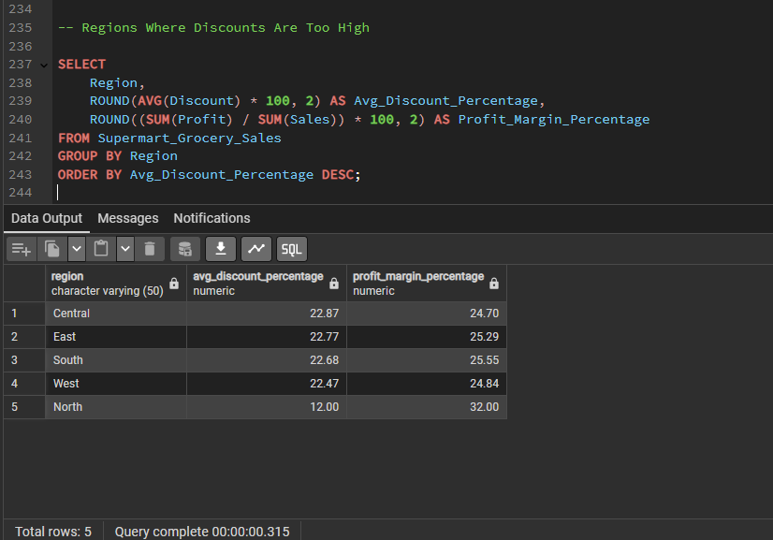

-- Regions with High Order Volume but Low Revenue

SELECT Region,

COUNT(Order_ID) AS Total_Orders,

SUM(sales) AS Total_SAles,

ROUND(AVG(sales), 2) AS Average_Order_Value

FROM

Supermart_Grocery_Sales

GROUP BY Region

ORDER BY Average_Order_Value ASC;

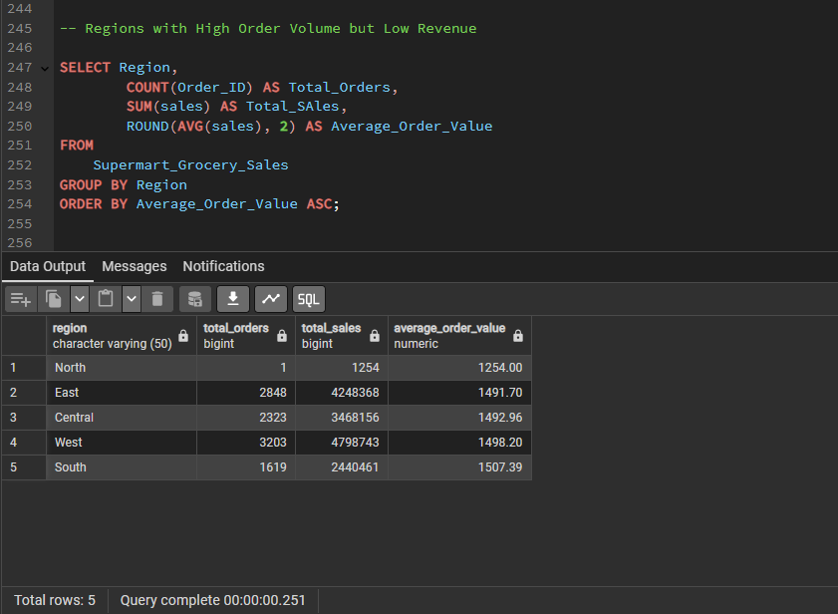

--the Worst Performing 3 Regions Based on All Metrics

SELECT

Region,

SUM(Sales) AS Total_Sales,

SUM(Profit) AS Total_Profit,

ROUND((SUM(Profit) / SUM(Sales)) * 100, 2) AS Profit_Margin_Percentage,

ROUND(AVG(Discount) * 100, 2) AS Avg_Discount_Percentage

FROM Supermart_Grocery_Sales

GROUP BY Region

ORDER BY Total_Sales ASC, Profit_Margin_Percentage ASC

LIMIT 3;

